Exp no:6
Determination and plotting of Capacitance of parallel plate capacitor in three different dielectric medium with specific area, dielectric thickness and various dielectric constant.
Aim:
To write program for capacitance of parallel plate capacitor in three different dielectric media using SCILAB.

Software required:
•SCILAB version 6.0.1

Program: 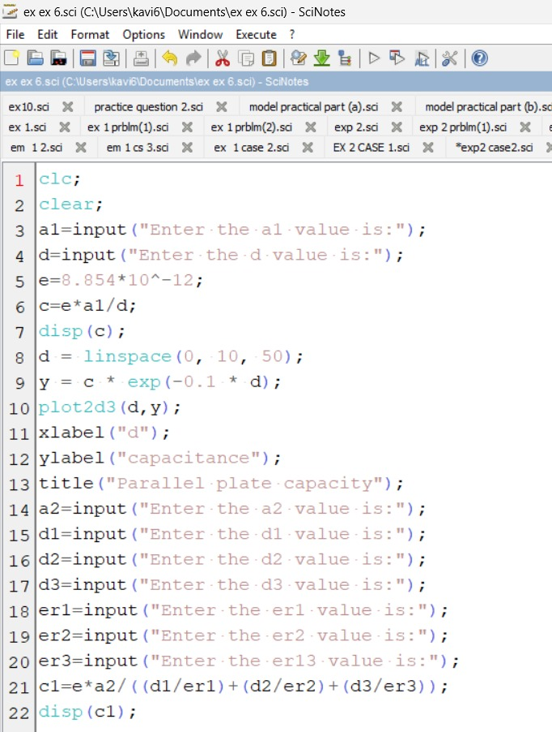
Output:-
Enter the a1 value is:4cm^2
Enter the d value is:2mm

0.00001771

Enter the a2 value is:6m^2
Enter the d1 value is:3mm
Enter the d2 value is:4mm
Enter the d3 value is:6mm
Enter the er1 value is:3
Enter the er2 value is:2
Enter the er13 value is:5

0.0001265
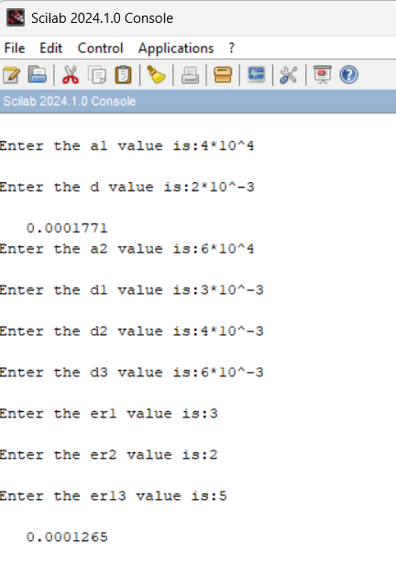
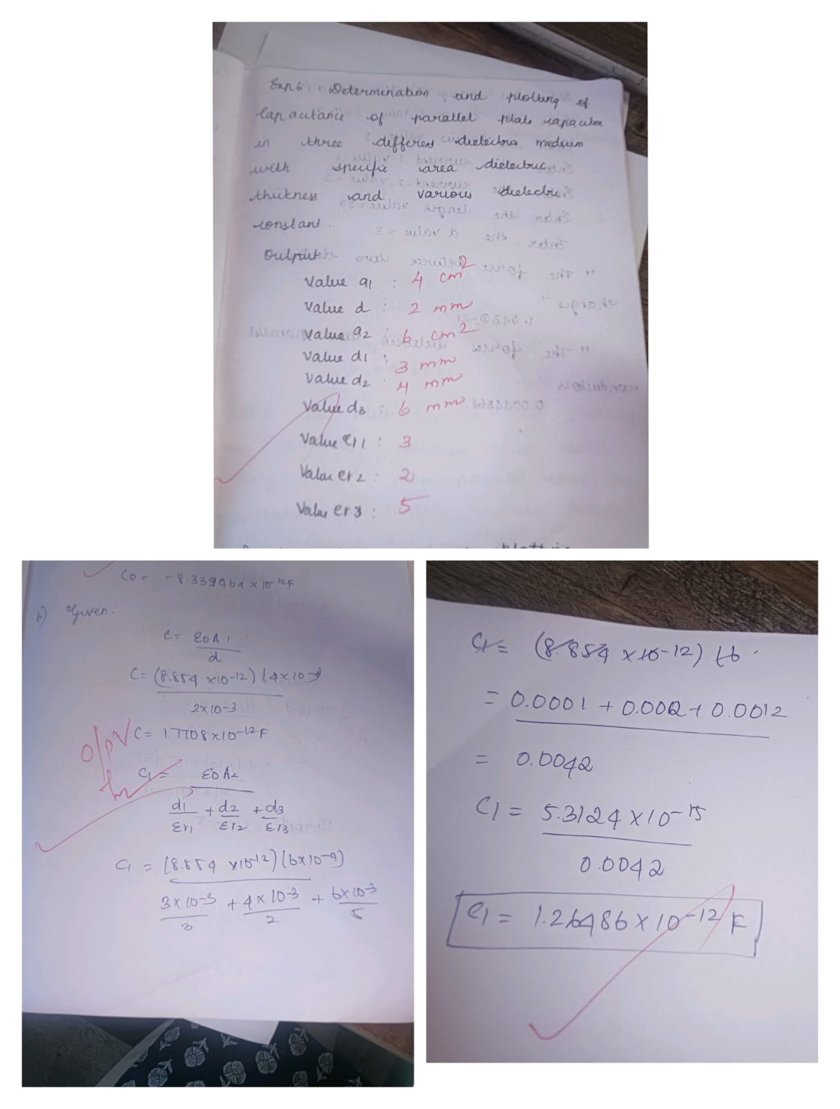

Determination and plotting of Capacitance of parallel plate capacitor in three different dielectric medium with specific area, dielectric thickness and various dielectric constant
CODE:
Case 1. AIR
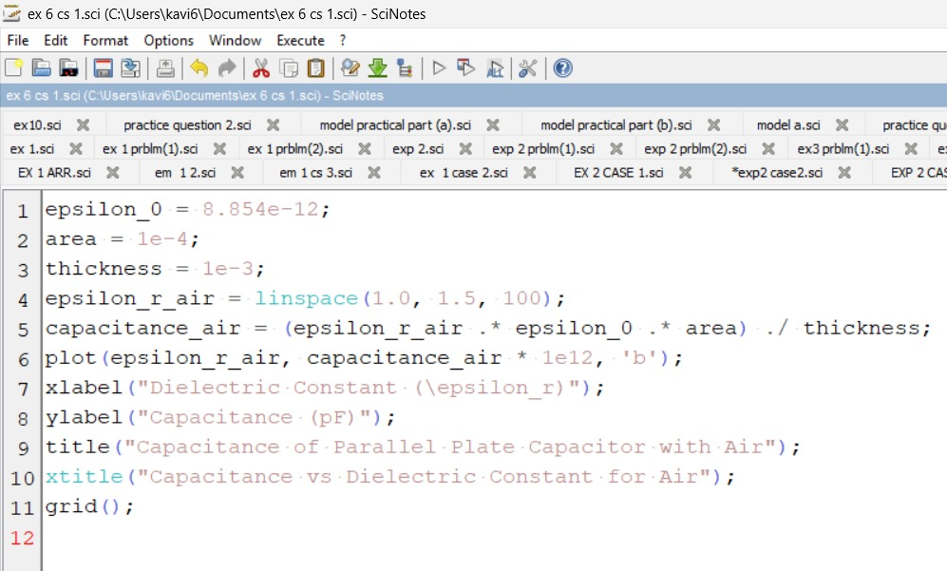 OUTPUT:
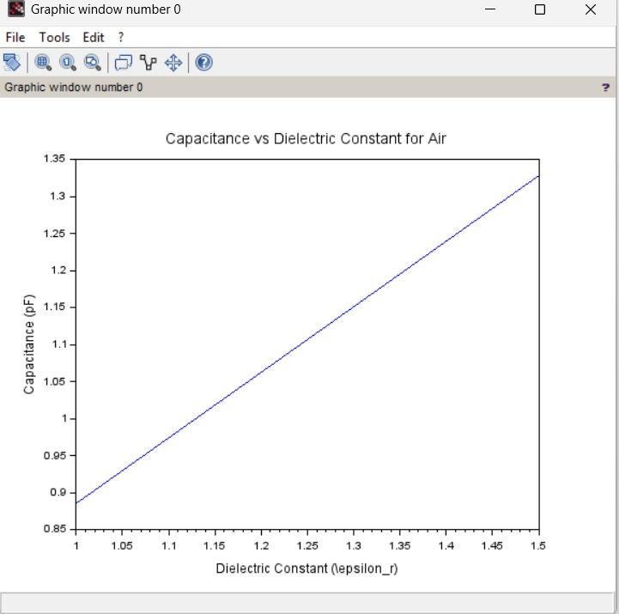
Case 2. Glass:
OUTPUT
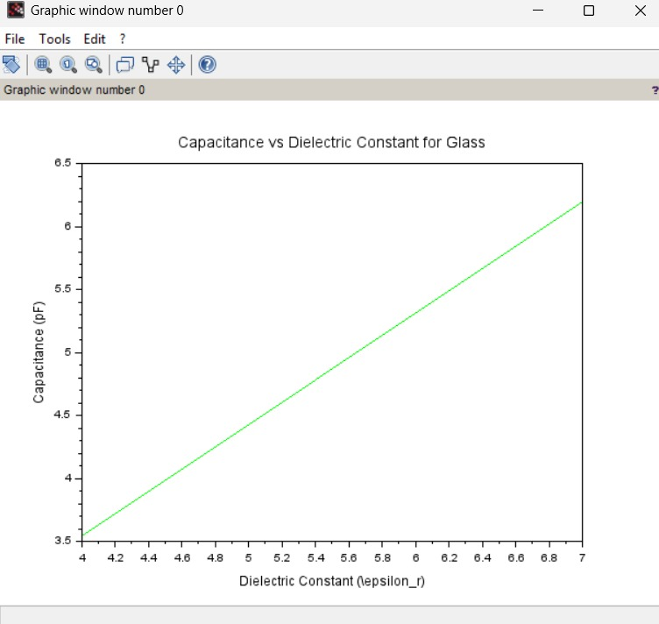

Case 3. Teflon:
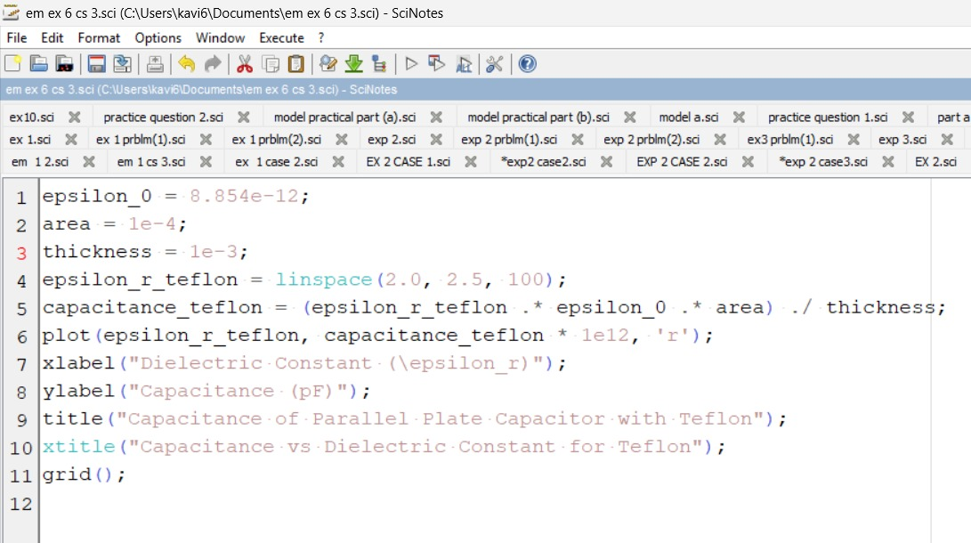
OUTPUT:
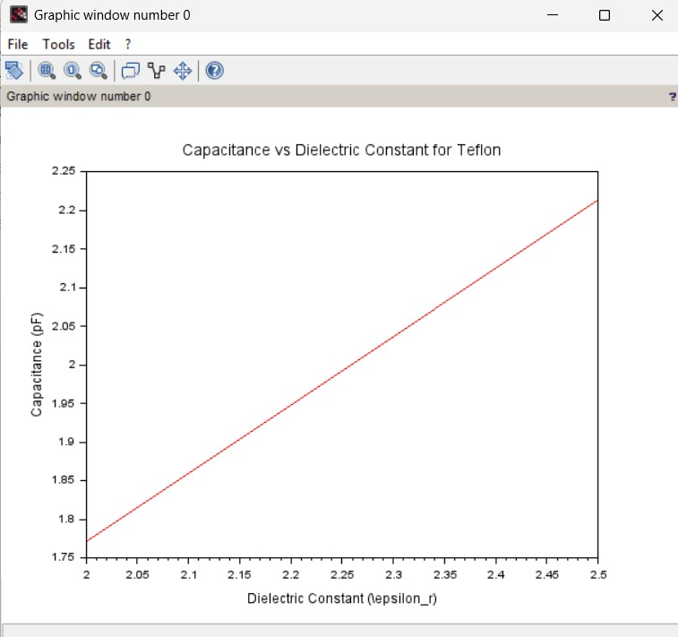

Result :
Thus the program was verified for capacitance of parallel plate capacitor in three different dielectric media using SCILAB was successfully.

